Name: _______________________________________Per: ______ Date: __________________
ATOMIC RADIUS AND IONIZATION ENERGY TREND WORKSHEET
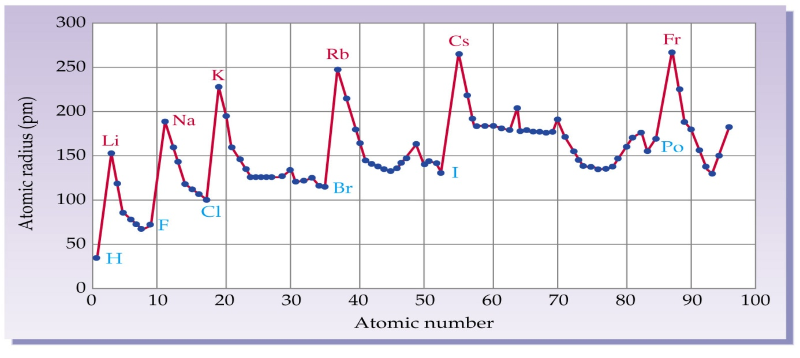

- Which has a larger radius Na (#11) or Li (#3)? Why?

- Which has a larger radius Mg (#12) or Cl (#17)? Why?

- Which has a smaller radius P (#15) or S (#16)? Why?

- Loot at the atom radii for H, Li, Na, and K.
  - What conclusions can you draw about atom radius within a column?

  - Could you draw the same conclusion about Be, Mg, and Ca?

  - Could you draw the same conclusion about F, Cl, and Br?

  - What is the reason to explain the conclusion you have reached about atom radius within a column?

- Look at the atomic radii for elements in period 1.
  - What conclusions can you draw about atom radius within the first period?

  - Is your conclusion the same for the elements in period 3?

  - What explanation do you have for the conclusions you have drawn about atom radius within a period?
- Arrange the following elements in order of INCREASING atomic radius: Ba (#56), S (#16), Te (#52), Al (#13), Br (#35), F (#9)

- Arrange the following elements in order of DECREASING atomic radius: Au (#79), Ni (#28), Ho (#67), At (#85), C (#6), Np (#93)
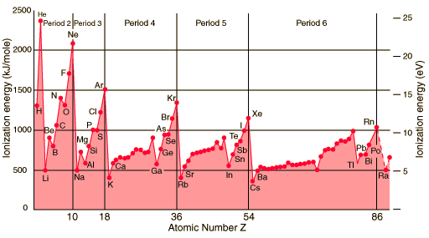

- Look at the elements Li, Na, and K.
  - What conclusion can you draw about ionization energy within a column?

  - Would you draw the same conclusion about O, S, and Se?

  - What reason can you give to support your conclusion about ionization energy within a column?

- Which has greater ionization energy Na or Mg? Why?

- Which has greater ionization energy Mg or Al? Why?

- Look at Al, Si, and P. What conclusions can you draw about ionization energy as the atomic number increases across a period?

- Why is there a slight fall-back in ionization energy between P and S on the graph?

- Using just the TREND, arrange the following in order of INCREASING ionization energy: Sr (#38), Pu (#94), As (#33), Po (#84), F (#9) and Li (#3)

